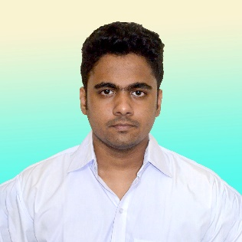

***Objective:***

Have a strong desire to work in such a site where I can develop my career through putting my skills, learning experience and all of my educational qualifications. To achieve this aim I'm fully determined to show honesty, efficiency and sincerity up to my optimal level.

***Job EXPERIENCE:***

Fresher.

***Qualification (s):***

* Office tool: MS word, Excel and Power point work
* Any format E-mailing and social site management
* Communication development
* Photoshop primary work

***Subjective Skill (s):***

* Proficient in Python, C, C++, Java.
* Have sound knowledge in Data Structures and Algorithms.
* Decent knowledge in Object Oriented Programming (OOP).
* Familiar with HTML, CSS, JavaScript and Tailwind CSS.
* Acquainted with tools such as Git, PyCharm, NetBeans, VS Code and MS Office.
* Can type at a decent speed of 70+ WPS.

***Project (s)***

Movie Booking Site

* Built a website using MERN stack
* Designed and Implemented an admin dashboard for managing movie tickets.
* Implemented session-based authentication for user interaction.
* Styled HTML using Tailwind CSS.

***Prsonal Strength (s):***

Communicative, Teamwork , Pressure Tolerance , Time Efficiency, Adaptability, Leadership

***Education Summary (s):***

**B.Sc Engineering | 2023**

Discipline: Computer Science and Engineering (CSE)

Session: 2017-2023

Institute: Mawlana Bhashani Science and Technology University

Location: Tangail, Dhaka, Bangladesh

Result: Appeared



**Rabbi Hossain Rakib**

Personal Information:

Permanent Address;

Village: Baruakhali; Post Office: Hat-Baruakhali; Police Station: Nobabganj, District: Dhaka.

Father's Name

Abdus Salam

Mother's Name

Monowara Begum

Gender

Male

Marital Status:

Unmarried

Language (s)

Bengali, English

House No: 24, Road No: 5B, West Dhanmondi Housing, Mohammadpur, Dhaka 1207.

+880 1687248854

rrakibb.rh@gmail.com



***Education Summary (s):***

**High School Certificate (HSC) | 2016**

Institute: Government Laboratory High School

Board: Dhaka

Major: Science

Result: CGPA (5.0/5.0)

**Secondary School Certificate (SSC) | 2014**

Institution: Govt. Science College attached High School

Board: Dhaka

Major: Science

Result: CGPA 5.0/5.0

***reference (s):***

**1. Md. Zakir Hossain**

B.Sc and M.Sc in Applied Physics, Electronics and Communication Engineering

University of Dhaka

Profession: AGM, DMSL (Hitachi Analytical Division)

Email: [zakaria.apece@gmail.com](mailto:zakaria.apece@gmail.com)

Cell No: +8801680-908926

**2. Md. Mosleh Uddin Rony**

Scientific Officer

Department of Fisheries

Ministry of Fisheries and Livestock

Contact- 01741-042987

-----------------------------------------

I hereby, declare that the information above is true to the best of my knowledge. If required and where applicable, these documents can be supported by appropriate authentic certificate/paper.

Thanking you,

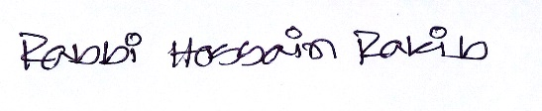

**Rabbi Hossain Rakib**

 Personal Information:

Present Address:

Dhanmondi Housing,

Mohammadpur, Dhaka

Nationality:

Bangladeshi

Blood Group:

A (+ve)

Height/Weight:

5' 7" / 68Kg

Religion:

Islam

Date of Birth:

13 January 1999

Interest:

Interested in DIY, Typing, Music, Travelling, Memes, Books.

Always looking forward to learn and explore new things.